**Maze solving Python code:**

**Sharif Mahmud**

**22010117**

**CSE 38th Batch**

**https://github.com/sharifosd/Maze-solving-python-Code**

**Code:**

import sys

class Node():

    def __init__(self, state, parent, action):

        self.state = state

        self.parent = parent

        self.action = action

class StackFrontier():

    def __init__(self):

        self.frontier = []

    def add(self, node):

        self.frontier.append(node)

    def contains_state(self, state):

        return any(node.state == state for node in self.frontier)

    def empty(self):

        return len(self.frontier) == 0

    def remove(self):

        if self.empty():

            raise Exception("empty frontier")

        else:

            node = self.frontier[-1]

            self.frontier = self.frontier[:-1]

            return node

class QueueFrontier(StackFrontier):

    def remove(self):

        if self.empty():

            raise Exception("empty frontier")

        else:

            node = self.frontier[0]

            self.frontier = self.frontier[1:]

            return node

class Maze():

    def __init__(self, filename):

        # Read file and set height and width of maze

        with open(filename) as f:

            contents = f.read()

        # Validate start and goal

        if contents.count("A") != 1:

            raise Exception("maze must have exactly one start point")

        if contents.count("B") != 1:

            raise Exception("maze must have exactly one goal")

        # Determine height and width of maze

        contents = contents.splitlines()

        self.height = len(contents)

        self.width = max(len(line) for line in contents)

        # Keep track of walls

        self.walls = []

        for i in range(self.height):

            row = []

            for j in range(self.width):

                try:

                    if contents[i][j] == "A":

                        self.start = (i, j)

                        row.append(False)

                    elif contents[i][j] == "B":

                        self.goal = (i, j)

                        row.append(False)

                    elif contents[i][j] == " ":

                        row.append(False)

                    else:

                        row.append(True)

                except IndexError:

                    row.append(False)

            self.walls.append(row)

        self.solution = None

    def print(self):

        solution = self.solution[1] if self.solution is not None else None

        print()

        for i, row in enumerate(self.walls):

            for j, col in enumerate(row):

                if col:

                    print("█", end="")

                elif (i, j) == self.start:

                    print("A", end="")

                elif (i, j) == self.goal:

                    print("B", end="")

                elif solution is not None and (i, j) in solution:

                    print("#", end="")

                else:

                    print(" ", end="")

            print()

        print()

    def neighbors(self, state):

        row, col = state

        candidates = [

            ("up", (row - 1, col)),

            ("down", (row + 1, col)),

            ("left", (row, col - 1)),

            ("right", (row, col + 1))

        ]

        result = []

        for action, (r, c) in candidates:

            if 0 <= r < self.height and 0 <= c < self.width and not self.walls[r][c]:

                result.append((action, (r, c)))

        return result

    def solve(self):

        """Finds a solution to maze, if one exists."""

        # Keep track of number of states explored

        self.num_explored = 0

        # Initialize frontier to just the starting position

        start = Node(state=self.start, parent=None, action=None)

        frontier = StackFrontier()

        frontier.add(start)

        # Initialize an empty explored set

        self.explored = set()

        # Keep looping until solution found

        while True:

            # If nothing left in frontier, then no path

            if frontier.empty():

                raise Exception("no solution")

            # Choose a node from the frontier

            node = frontier.remove()

            self.num_explored += 1

            # If node is the goal, then we have a solution

            if node.state == self.goal:

                actions = []

                cells = []

                while node.parent is not None:

                    actions.append(node.action)

                    cells.append(node.state)

                    node = node.parent

                actions.reverse()

                cells.reverse()

                self.solution = (actions, cells)

                return

            # Mark node as explored

            self.explored.add(node.state)

            # Add neighbors to frontier

            for action, state in self.neighbors(node.state):

                if not frontier.contains_state(state) and state not in self.explored:

                    child = Node(state=state, parent=node, action=action)

                    frontier.add(child)

    def output_image(self, filename, show_solution=True, show_explored=False):

        from PIL import Image, ImageDraw

        cell_size = 50

        cell_border = 2

        # Create a blank canvas

        img = Image.new(

            "RGBA",

            (self.width * cell_size, self.height * cell_size),

            "black"

        )

        draw = ImageDraw.Draw(img)

        solution = self.solution[1] if self.solution is not None else None

        for i, row in enumerate(self.walls):

            for j, col in enumerate(row):

                # Walls

                if col:

                    fill = (40, 40, 40)

                # Start

                elif (i, j) == self.start:

                    fill = (255, 0, 0)

                # Goal

                elif (i, j) == self.goal:

                    fill = (0, 171, 28)

                # Solution

                elif solution is not None and show_solution and (i, j) in solution:

                    fill = (220, 235, 113)

                # Explored

                elif solution is not None and show_explored and (i, j) in self.explored:

                    fill = (212, 97, 85)

                # Empty cell

                else:

                    fill = (237, 240, 252)

                # Draw cell

                draw.rectangle(

                    ([(j * cell_size + cell_border, i * cell_size + cell_border),

                      ((j + 1) * cell_size - cell_border, (i + 1) * cell_size - cell_border)]),

                    fill=fill

                )

        img.save(filename)

if len(sys.argv) != 2:

    sys.exit("Usage: python maze.py maze.txt")

m = Maze(sys.argv[1])

print("Maze:")

m.print()

print("Solving...")

m.solve()

print("States Explored:", m.num_explored)

print("Solution:")

m.print()

m.output_image("maze.png", show_explored=True)

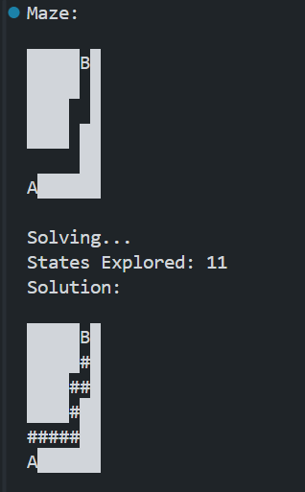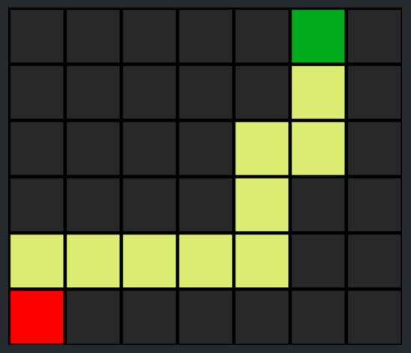**output :  
  
Example 1:**

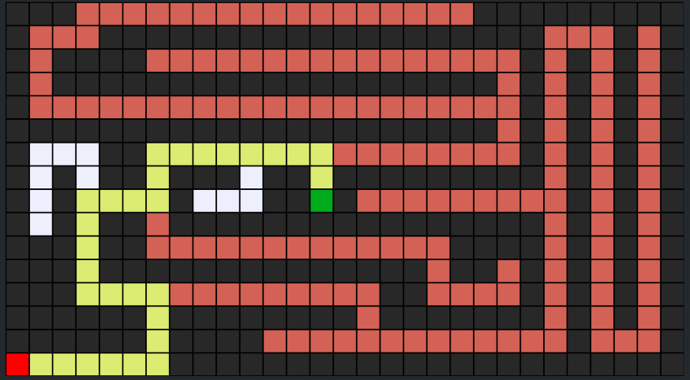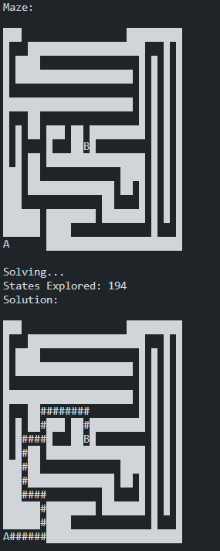**Example 2:**

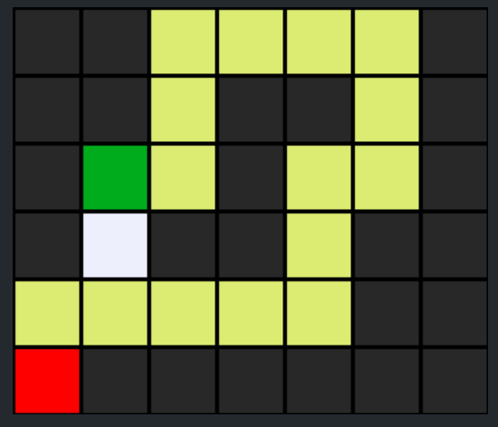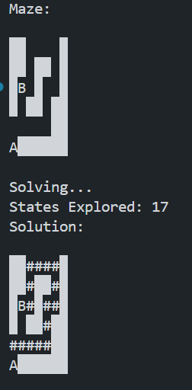**Example 3:**

**Maze Solver**

**This project implements a maze-solving algorithm using depth-first search (DFS) or breadth-first search (BFS) to find a path from a starting point ('A') to a goal point ('B') in a text-based maze.**

**Features**

**Reads maze from a text file.**

**Visualizes the maze and the solution.**

**Outputs the number of states explored during the search.**

**Requirements**

**Python 3.x**

**Pillow (for image generation)**

**You can install the required package using pip: pip install Pillow**

**Classes**

**Node:**

**Represents a state in the maze. Each node keeps track of its state (position), parent node, and action (movement direction).**

**StackFrontier:**

**Implements a stack to explore nodes in a Depth-First Search (DFS) manner.**

**QueueFrontier:**

**Inherits from StackFrontier and implements a queue to explore nodes in a Breadth-First Search (BFS) manner.**

**Maze:**

**Manages the maze structure, initializes the maze from the file, and provides methods to solve the maze, print the solution, and output an image.**

**Functions**

**init(filename):**

**Initializes the maze by reading the input file, determines the start and goal positions, and stores the maze structure.**

**solve():**

**Solves the maze using DFS (or BFS if QueueFrontier is used). Explores nodes, keeps track of visited nodes, and finds the solution.**

**neighbors(state):**

**Returns all possible valid moves from a given state.**

**print():**

**Prints the current state of the maze, including the solution path.**